Student Resource Book
UEEIC0013

Develop enter and verify discrete control programs for programmable logic controllers.

22519VIC
Certificate IV in Integrated Technologies
Introduction
A composite
Training Resource

Student Name:
© North Metro TAFE
Acknowledgements
This workbook was produced by Ron McGrechan with North Metropolitan TAFE for educational purposes.
It is intended for use by North Metropolitan TAFE students only.
COPYRIGHT STATEMENT
All rights reserved. Apart from any use as permitted under the Copyright Act 1968, no part may be reproduced without the prior written permission of North Metropolitan TAFE.
This permission does not extend to the making of copies for use outside the immediate training environment for which they are made, or the making of copies for hire or resale to third parties.
Requests and inquiries concerning other reproduction and rights should be directed in the first instance to the Manager Publications and Distributions.
Manager Publications and Distributions
North Metropolitan TAFE
Locked Bag 6, Northbridge
Western Australia 6865
Disclaimer:
Whilst every effort has been made to ensure the accuracy of the information contained in this publication, no guarantee can be given that all errors and omissions have been excluded. No responsibility for loss occasioned to any person acting or refraining from action as a result of the material in this publication can be accepted by North Metropolitan TAFE.
COMMONWEALTH OF AUSTRALIA
Copyright Regulations 1969
WARNING
This material has been copied and communicated to you by or on behalf of Polytechnic West pursuant to a statutory license under the Copyright Act 1968 (the Act). The material in this work may be subject to copyright under the Act. Any further copying or communication of this material by you may be the subject of copyright protection under the Act.

Develop enter and verify discrete control programs for programmable logic controllers. 1
1.0 PLC Exercises 4
2.0 History 5
3.0 PLC Structure 9
4.0 PLC Cycle 11
5.0 PLC Languages 13
6.0 Variables 16
7.0 Failsafe connections 17
8.0 Digital input wiring 18
9.0 Digital output modules 20
10.0 Analogue modules 23
11.0 Communications 30
12.0 Binary 33
13.0 System 33
14.0 Truth Table 33
15.0 Numbering Systems 34
16.0 Mathematical Functions using Computers. 38
17.0 Introduction to Logic Circuits 40
18.0 Self-assessment Questions 45
Appendix A 47
Glossary 49

1.0 PLC Exercises

1.1 Overview
Programmable Logic Controllers are used on many sites. The instrumentation technician may find it useful to understand how they operate, how they are programmed and how to troubleshoot problems using the features of the PLC. You may be required to install PLCs and may be required to write the programs. You will probably have to view an existing system and interpret how it works so that you can fault find equipment. There are many manufacturers of PLCs and they all of them have special ways of doing things. However, they are also similar in many ways and even though this course uses one type of PLC we have tried to focus on the basics and use it as a steppingstone to you being more confident to become more familiar with the PLC that you end up using.

1.2 Aim
The aim of this document is to provide you with some exercises in writing PLC programs in Ladder and Function Block programming styles. The exercises take you from never writing a program, to writing a digital program, to writing a program that uses analogue values and then completing the assessments.

1.3 Your Place or Ours
PLCnext Technology is the ecosystem for industrial automation consisting of open hardware, modular engineering software, a global community, and a digital software marketplace. Digitalization and globalization are placing new demands on industrial automation. The precisely tailored design of the open automation system is just as important as flexible, modular expansion. In addition to standard programming of PLC systems in accordance with IEC 61131-3, parallel programming, and the combination of programming languages such as C/C++, C#, and MATLAB® Simulink® in real-time is also possible with PLCnext Control.
Accelerate your application development process with the free basic version of PLCnext Engineer. Or use your familiar programming environment – you decide!
Through simple cloud integration, the option to use open-source software, and the constantly growing expertise of the PLCnext Community, you thus benefit from new forms of collaboration.

1.4 Hardware
The software has a simulator included so it is not necessary to have access to the hardware.

1.5 Structure
This document can be used as the only source of information; however, videos have been produced that support the information in this document. There are a series of exercises that lead the student through the material so that can be prepared for the assessments.

2.0 History
There is a perception that computing is a new science that started in the late 1970’s and just appeared full grown from nothing. In actual fact, like all things, there was a slow evolution.
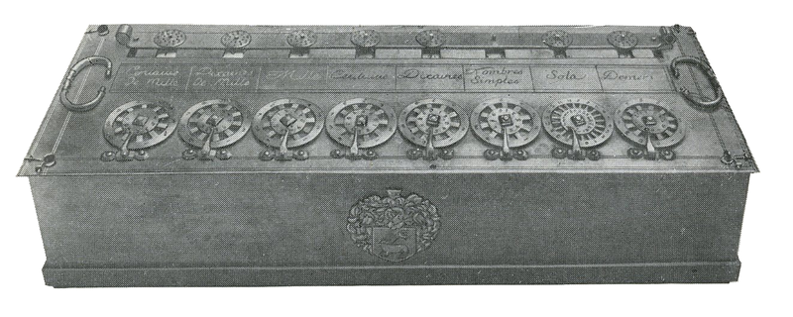
public domain - published in USA before 1923
As long ago as 1642, Blaise Pascal invented the first pocket calculator (they had BIG pockets in those days). This mechanically driven machine could add, subtract, multiply and divide to 4 decimal places.

1832: Charles Babbage built the first proper computer, the “Difference Engine”, it was capable of performing calculus using the principle of differences. Unfortunately, he could not make it work. Luckily, he met Ada Lovelace at a dinner party. Ada was the daughter of Lord Byron. Her mother divorced Byron after catching him making love to his own sister. Ada was educated at the best schools and universities, she was a mathematical genius.
1854: The mathematician George Boole published a book “Mathematical Analysis of Logic “this set out the ideas of logical thought and binary decision making. (See: Introduction to Logic Circuits, below).
The American census of 1880 took seven years to complete. It was estimated that the next census would take thirteen years. Luckily the Hollerith’s tabulating machine, using punched cards was invented. The 1890 census was completed in eighteen months after double checking the results.
The advantages of the technology were immediately apparent for accounting and tracking inventory. Hollerith set up a company to market his invention. The first automatic feed tabulator, operating at 150 cards/minute, was developed in 1906.

Introduced in 1934, the 405 Alphabetical Accounting Machine was the basic bookkeeping and accounting machine marketed by IBM for many years. Important features were expanded adding capacity, greater flexibility of counter grouping, direct printing of entire alphabet, direct subtraction and printing of either debit or credit balance from any counter. Commonly called the 405 "tabulator," this machine remained the flagship of IBM's product line until after World War II.

Hollerith's company eventually became a part of International Business Machines, which developed faster and faster tabulators until the invention of the electronic computer in the 1940s.

1938: The German navy used the Enigma machine to code their radio transmissions. Enigma was designed to defeat basic cryptanalytic techniques by continually changing the substitution alphabet. Like other rotor machines, it implemented a polyalphabetic substitution cipher with a long period. With single-notched rotors, the period of the machine was 16,900 (26 × 25 × 26). This long period helped protect against overlapping alphabets.

The Enigma machines added other possibilities. Each rotor had a variable starting position (e.g., ABC, as opposed to ACB); later Enigma models added a variable alphabet ring to each rotor. Most of the military Enigmas also featured a plugboard (German: Steckerbrett) which exchanged letters. Even so, this complex combination key could be easily communicated to another user, comprising as it did only a few simple items: rotors to be used, rotor order, ring positions, starting positions, and plugboard connections. Potentially this made the Enigma an excellent system.
Public Domain Published in the US prior to 1923
Span
Adjust
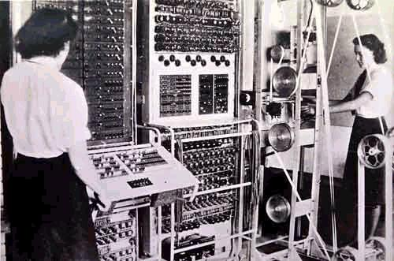
Colossus used state-of-the-art vacuum tubes (thermionic valves), thyratrons and photomultipliers to optically read a paper tape and then applied a programmable logical function to every character, counting how often this function returned "true". Although machines with many valves were known to have high failure rates, it was recognised that valve failures occurred most frequently with the current surge at power on, so the Colossus machines, once turned on, were never powered down unless they malfunctioned.
Span
Adjust

Colossus was the first of the electronic digital machines to feature limited programmability. However, it was not a fully general-purpose computer, not being Turing-complete, even though Alan Turing, on whose research this definition was based, worked at Bletchley Park where Colossus was put into operation. It was not then realized that Turing-completeness was significant; most of the other pioneering modern computing machines were not either (e.g., the Atanasoff–Berry Computer, the Harvard Mark I electro-mechanical relay machine, the Bell Labs relay machines (by George Stibitz et al), Konrad Zuze’s first two designs, and so on). The notion of a computer as a general-purpose machine, and not simply a massive calculator devoted to solving difficult but single-minded problems, did not become prominent until a few years later.

Colossus was preceded by several computers, many of them first in some category. Zuze’s Z3 was the first functional fully program-controlled computer, and was based on electromechanical relays, as were the (less advanced) Bell Labs machines of the late 1930s (George Stibitz, et al). The Atanasoff–Berry Computer was electronic and binary (digital) but not programmable. Assorted analogue computers were semi programmable; some of these much predated the 1930s (e.g., Vanover Bush). Babbage's Analytical engine predated all these (in the mid-1800s), and was both digital and programmable, but was only partially constructed and never functioned at the time (a replica of his Difference engine No. 2, built in 1991, does work, however). Colossus was the first combining digital, (partially) programmable, and electronic. The first fully programmable digital electronic computer was the 1948 Manchester Small Scale Experimental Machine.



Zero
Adjust

During the latter part of the Second World War, the US Navy commissioned a computer to help them with gunnery and flight problems. This was the super-secret Project Whirlwind. Before the computer was delivered; it was redirected to another even higher priority project The Manhattan Project.

In the late fifties, the Ford Motor Company needed a way to speed up the retooling time needed to modify production lines. The critical time-consuming element proved to be rewiring the relay logic. They put a tender out for a Programmable Logic Controller (a computer with software relays). This tender was won by the Modicum Corporation who produced the Modicum 084. The Modicum name has changed hands many times and is currently held by Schneider.

3.0 PLC Structure
Output
Memory
Communication
Input
CPU

A PLC structure is like most computer structures. It has inputs, outputs, central processing unit (CPU), memory and communication.

Inputs – The inputs can be digital (on/off), analogue inputs accept current or voltage values that are changed into numbers. PLCs can have special inputs that can take temperature probes.

Outputs – The outputs can be digital or analogue.

CPU – Central Processing Unit is the brain of the PLC that performs the functions of the operating system such as reading inputs and updating outputs. It runs the programs that you the user program into the PLC.

Memory– This is where the PLC stores the operating system, user programs, and data created when the programs run and the input and output values. The manipulation of data occurs in the CPU and not in memory. The memory usage could look similar to the following. Each memory location has 8 bits of data and has a unique address.

Operating System
Input and Output
User Program
User Storage
CPU

All program control and calculations are done in the CPU.

Communication– The communication allows the PLC to communicate with a computer so that programs can be downloaded and uploaded. The operation of the PLC can be monitored on the computer. The PLC can transfer data between other devices via different protocols such as Profibus, Modbus, Ethernet etc.

4.0 PLC Cycle

Read Inputs and Update any Changes.
Run the Program
Send any Changes to the Outputs
The PLC does not perform all its tasks at the same time but performs each task sequentially. Firstly, the inputs are scanned, and any changes are flagged. The main program then runs and as a result changes to the outputs are flagged. Any changes are sent to the output channels. The cycle is then repeated and continues until the program is halted.
This happens very quickly and gives the impression that everything is happening at the same time. If an input changes state and reverts back to the original whilst the processor is in the “Run the Program” phase or the “Output Phase” the change will go unnoticed; normally this would not be a problem unless the program cycle is particularly long. The use of good programming structure can reduce the time of the “Run the Program” phase and speed up the operation.

4.1 Example
There is an assembly line that has a sensor detecting objects and at normal speed our sensor is on for 0.75 seconds. If the run cycle and the output cycle are long enough it is possible that the change in the input sensor could be missed.
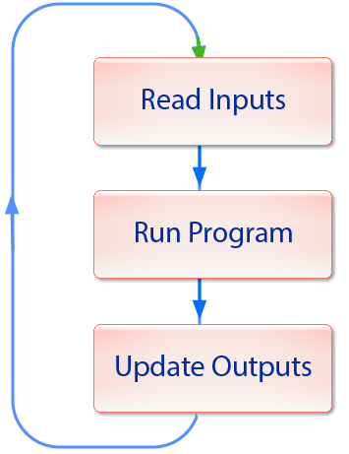
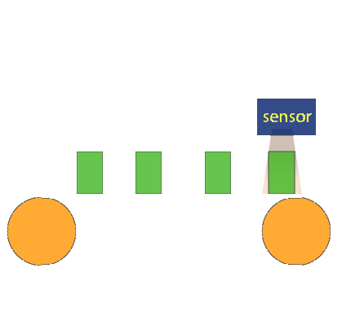
The sensor is on for 0.75 seconds.

4.2 Solutions
- Use a delay circuit from the sensor to keep the input on long enough so that the PLC doesn’t miss the signal.
Delay

- Use program structure to speed up the time that the PLC runs the program. In this example parts of the program are put in sub routines and are only used if that operation is required.
PLC Program
PLC Program
Subroutine 1
Subroutine 2

- It may be time to upgrade the PLC to a newer faster model.


5.0 PLC Languages
There is an international standard IEC-61131-3 that sets the requirements for PLC programming languages. Each manufacturer is required to meet these minimum standards so that there is a commonality with language types.
There are 5 language types that can be put into 3 categories.
- Text Based Languages
  - Instruction list
  - Structured text
- Graphical based languages
  - Ladder diagram
  - Function block diagram
- Sequential flow control
Consider the start stop electrical circuit and look at how each language would perform that function.
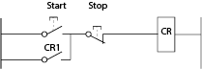

5.1 Instruction list
Instruction list is a series of 2 to 3 letter codes that describe a PLC function. There are operands that are variables that contain data that the instructions manipulate. The operands can relate to external inputs and outputs or internal functions. This language close to assembly language which is similar to the machine code that the CPU uses.
Label | Instruction | Operand | Comment
Pump: | LD | Start | (*load the Start variable*)
 | OR ( | CR | (* OR start with the output pump*)
 | )
 | AND ( | Stop | (* AND the result with the Stop variable*)
 | )
 | ST | CR | (*Store the result in pump*)

5.2 Structured text
Structured text is a high-level text-based language that is similar to and uses the same rules of the “C” programming language.
Pump: = (Start OR CR) AND Stop ;(* Start Stop program *)

5.3 Ladder diagram
This graphical language that is structured similarly to the relay logic diagrams used by electricians. It uses symbols that look like capacitors for the input contacts and uses symbols with brackets that represent coils. The inputs are on the left and outputs are on the right. There are vertical power rails on the left and right. Inputs and outputs are shown on horizontal rungs. Each rung must have an output as a minimum.
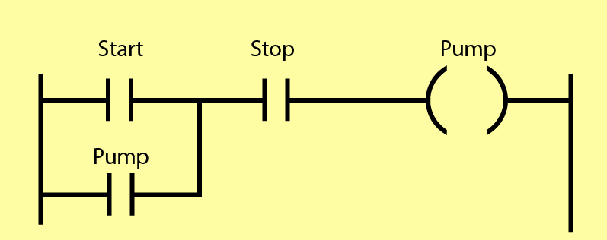

5.4 Function block diagram
Library functions are provided to perform the operations on the inputs and outputs. Connections between the boxes can be made by drawing interconnecting lines or by the use of variables.
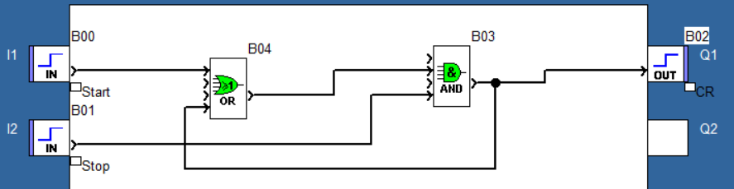

5.5 Sequential flow control
Sequential flow control is a way to structure the program for controlling a process that has functions that are required to operate in a sequence. The operation would be divided into a series of steps. When a step is completed, a signal is returned to init1ate the transition to the next step. Processes can be set to occur one step at a time, or a transition may initiate processes.
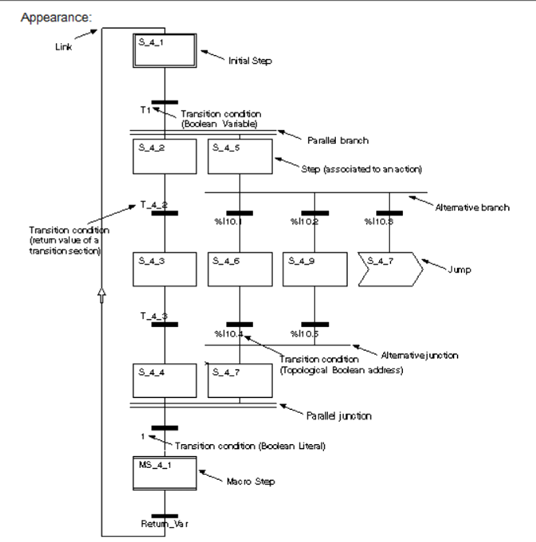

6.0 Variables
A variable is a piece of data that is stored in the computer or PLC. We need a way for the computer to retrieve the data stored in memory, so we give it a name or label. The variable name can be up to 32 characters. (Spaces and punctuation marks are not allowed.) The underscore can be used instead of a space. Upper- and lower-case letters and numbers are allowed although the first character must be a letter. Descriptive names or tag names should be used.
For example, Pump_2_On, Upper Tank Level, LT206.

Normally the inputs, outputs and variable names are set at the planning stage, however, variables can be added at any stage during the development stage and I/O can be assigned at any time.

6.3 Data Types

For information on the different types of variables refer to Appendix A.

6.4 Addressing

6.5 Access syntax
- M, internal variables – a value stored in memory that can change as the program runs.
- K, for constants – a value stored in memory that will not change as the program runs.
- S, for system variables – variables that can be accessed that store the current status of the PLC and its operating system.
- N, for network variables – values that are used and accessible by the network.
- I, for input variables – the values that are read from the input devices.
- Q, for output variables – the values that are written to the output devices.

7.0 Failsafe connections

Taking a look at this latching circuit a normally closed switch is used for the stop so that if the switch fails then the circuit will be in a safe condition with the output off.
Consider the diagram below where the switches are connected to the input of the PLC. Normally closed switches are used for the “Stop” and “E-Stop” switches so that if they fail the device will be in a safe condition. Look at the PLC program and the ladder diagram shows normally open contacts for the “Stop” and “E-Stop”. The real switches are on so there is a connection so if the “Start” button is pressed then there is a connection through to the “Motor” coil. Pressing the “Stop” or “E-Stop” will break the connection. The PLC program is a replacement for the wiring.

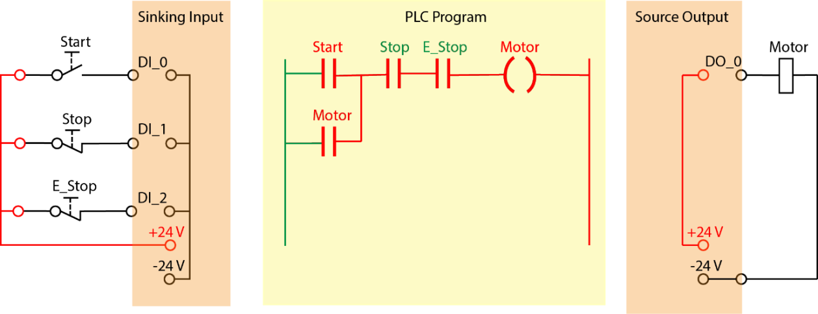

7.1 Safety of machinery
AS/NZS 4024.1604:2014 Section 4.1.6
Once active operation of the emergency stop device has ceased following an emergency stop command, the effect of this command shall be sustained until the machine is reset. Reset shall be possible only at that location where the emergency stop was initiated. The reset of the command shall not restart the machinery but only permit restarting. It shall not be possible to restart the machine until a manual reset of the emergency stop device has been performed at each location at which the emergency stop was activated.

7.2 Sinking and Sourcing
Using the convention that positives and actives are switched, for the inputs the +24 volts supply is connected to all the switches. The PLC inputs sink the current when the switch is on.
The output circuit switches the +24 volts and so becomes a source of current for the output load. The -24 volts supply is connected to all the PLC outputs.

8.0 Digital input wiring

8.1 DC Input
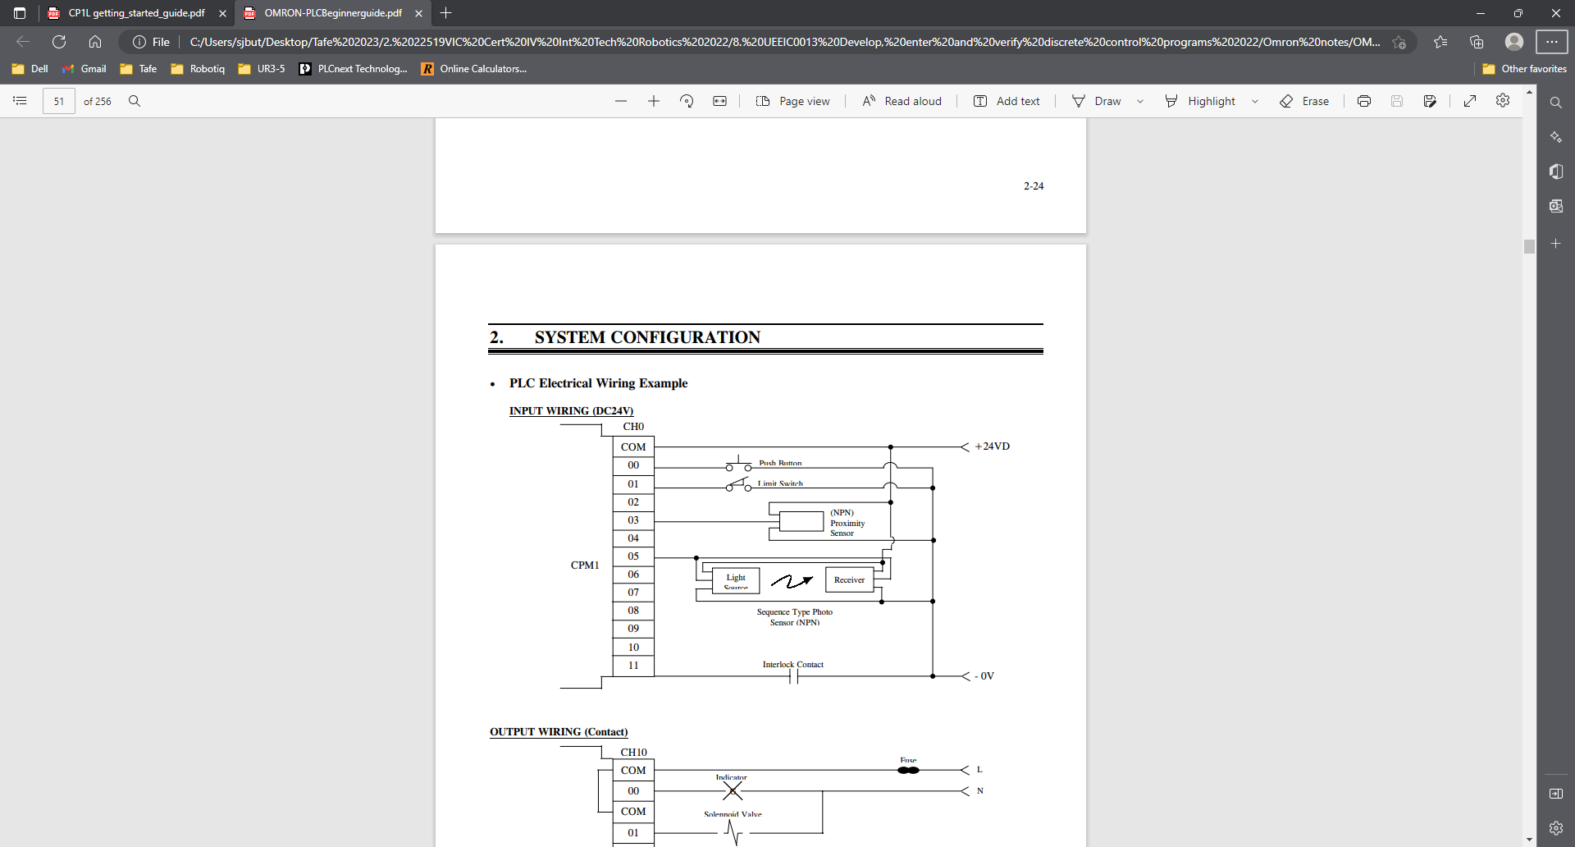
It is recommended that the plus 24 volts supply is fused and connected to all the external input switches. The negative 24 volts is common to all the inputs.

This is a typical circuit used for the DC input. Overvoltage protection provided by the Zener diode across the input. This input circuit is not suitable for AC input.

8.2 AC input
This module is suitable for alternating current to be connected to the input. It is recommended that each input is fused.

This is a typical input circuit for an AC input. It has an opto-coupler to provide isolation of the PLC circuitry from the external input. The opto-coupler has diodes with reversed polarities in parallel so that both the positive and negative half cycles are transferred to the input circuit. A varistor is provided for voltage protection of the input. This input device will operate with both AC and DC input.

9.0 Digital output modules
The out circuit of the digital are typically one of the following.
- Transistor output suitable for low currents and DC only.
- Relay output suitable for AC or DC.
- Triac output suitable for AC only.

9.1 Transistor output
It is recommended that the positive 24 volts supply is fused and connected to all the input common. The negative 24 volts is common to all the outputs. It is recommended that interposing relays are used so that higher currents can be switched.

9.2 Relay output module
Each output should be fused, and an interposing relay used. A diode and varistor should be used for circuit protection.

This is a typical output module circuit diagram using relay switching of the output.

9.3 Triac output module
Every 4 outputs have a common return. It recommended that an interposing relay is used with suitable protection to prevent Back EMF from the relay coil causing damage to the output circuit. Triac switching will only operate with alternating current.

10.0 Analogue modules
Analogue signals are typically one of the following.
- +/-10 V
- 0..10 V
- 0..5 V
- 0..20 mA
- 1..5 V
- 4..20 mA
- +/- 5 V
- +/- 20 mA

Since digital values have discrete steps, ADC’s and DAC’s convert in steps. The size of these steps is dictated by the number of binary digits used. The more digits used, the higher the resolution, the smoother (less steppe) the analogue value.

No of Bits | range | % Resolution
8 | 0-255 | 100% / 256 = 0.4 %
12 | 0-4095 | 100% / 4096 = 0.024%
14 | 0-16383 | 100% / 16383 = 0.0061%
16 | 0-65535 | 100% / 65536 = 0.0015 %

10.1 Analogue Input
This is a typical analogue input module. Usually there is only one analogue to digital converter and a multiplexer that switches the inputs to the ADC in a cyclic rotation.

The input is typically connected with shielded twisted pair cable. This input circuit shows that the negative inputs are internally connected to the shield cables via a filter circuit. Also, the input shields are earthed at the PLC.

Input 1 of this device has a voltage input that is connected to terminals 1 and 2. Terminal 3 has a 250-ohm resistor connected internally between terminals 2 and 3. The second input is connected for current input and so terminals 7 and 9 are externally connected. The 250-ohm resistor between terminals 8 and 9 provides a series circuit for the transmitter and power supply.




24VIECinput
+-

F1AT
SubD25
250R
250R
250R
IV0
IC00V0
Chan0
IS0
IV1
IC10V1
Chan1
IS1 ... IV3 IC30V3
Chan3
IS3
2wirescurrent sensor
0V sensor
Voltage sensor
4wirescurrent sensor
DC/DC 24V
DC/DC 24V
DC/DC 24V
I Lim 25mA
I Lim 25mA
I Lim 25mA

10.2 Analogue output module
The digital words are processed and converted to either a voltage or current signal.

This diagram shows the PLC analogue output connections. It can be programmed to be either a voltage signal source or a current signal source. Output 0 is a voltage source and Output 1 is a current source.

11.0 Communications
The wiring rules AS 3000:2007- Section 3.9.8.3 requires that low voltage and extra low voltage need to be segregated. However, this may be insufficient when communication cables are located near power cables.
The following table tries to categorise types of signals into their relative sensitivity to interference.
Highly sensitive | Sensitive | Less sensitive
RS485 | Digital inputs | AC Power
Profibus | Digital outputs | DC Power
Foundation Fieldbus
4 – 20 mA
RTD
Thermocouples
Pulse communication
Strain Gauge

11.1 Communication cables

Communication cables are shielded, and the individual pairs are twisted together.

11.2 Magnetic interference
An alternating current flowing down a conductor result in an alternating magnetic field being generated around the conductor. Currents can be induced into nearby cables. By twisting the pairs, the resulting induced currents tend to cancel out.
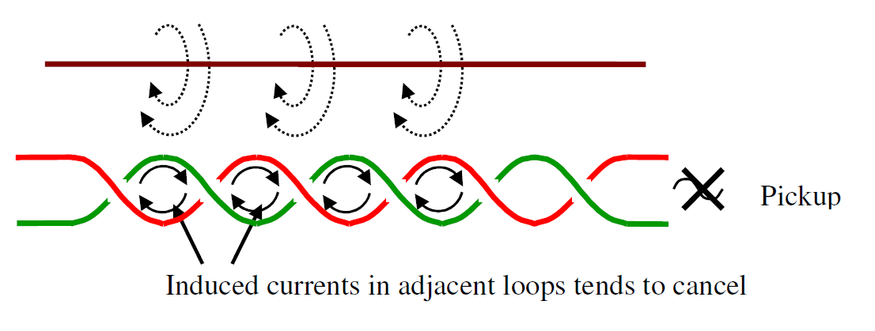

11.3 Electrostatic interference
If two conductors are separated by an insulator, then a capacitor is created. Capacitors provide a low impedance path to AC signals and so there is a signal transferred from on to another. An electrostatic shield provides a barrier so that the induced signal passed to ground.
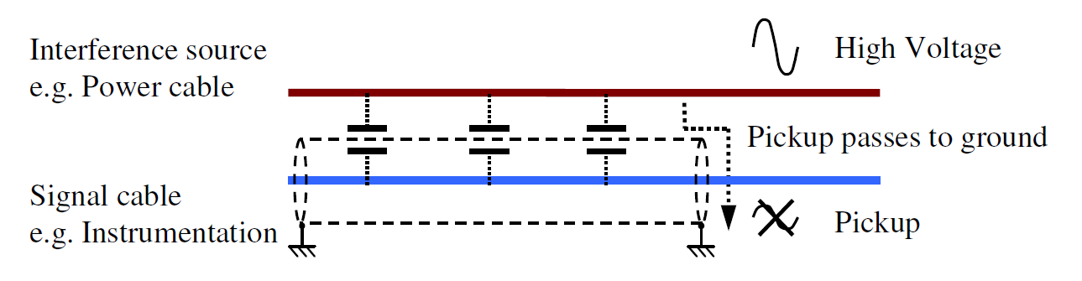
Communications signals carrying data would normally be earthed at both ends of the cable. Cables connecting sensors to PLC would be earthed only at one end at the PLC.

11.4 Separation by distance
An efficient method to reduce interference is to separate highly sensitive cables from less sensitive cables. The following tables provides a minimum recommended separation.
 | Highly sensitive | Sensitive | Less Sensitive
Highly sensitive  - Metal conduit  - Tray / trench  - Plastic conduit | 0  0  0 | 75 mm  150 mm  100 mm | 300 mm  650 mm  450 mm
Sensitive  - Metal conduit  - Tray / trench  - Plastic conduit | 75 mm  150 mm  100 mm | 0  0  0 | 150 mm  200 mm  150 mm
Less sensitive  - Metal conduit  - Tray / trench  - Plastic conduit | 300 mm  650 mm  450 mm | 150 mm  200 mm  150 mm | 0  0  0

12.0 Binary

A binary system has two possible states. With an electrical system it can have two states on and off. A switch can be on or off. We can also represent the switch to be “on or off”, “Logic 1 or Logic 0”, “1 or 0” or “True or False”.
Computers use binary because the computer can deal with two states on and off.
On | Off
Logic 1 | Logic 0
1 | 0
True | False

13.0 System
We can use a block to represent a system. The system has inputs and outputs. The system has functions that take the information from the inputs to manipulate the outputs. The inputs are on the left and the outputs are on the right.
System
Inputs
Outputs

14.0 Truth Table
A truth table can be used to show the output conditions for all the possible input combinations. They can be used to determine if two systems are the same or if the system will work as expected with every input combination.
Input A | Input B | Output
0 | 0 | 0
0 | 1 | 1
1 | 0 | 1
1 | 1 | 1

15.0 Numbering Systems

We use a positional decimal numbering system. Decimal (from the Latin for ten) means that there are ten symbols (0, 1, 2, 3, 4, 5, 6, 7, 8 & 9). Positional means that the position of the digit dictates it size: 020 is different from 002 and 200. Each column to the left has ten times the value (hundreds, tens and units).

The only reason we use decimal is that (most) people have ten fingers and thumbs, many early cultures used a Duodecimal system (based on 12).

Many of the early computers were “analogue”; numbers were stored as voltages with ten possible levels. “Digital” computers soon gained dominance because they used only two voltage levels (volts or no-volts). Two voltage levels can be easily switched with simple devices such as relays. Numbers were stored in digital computers using binary numbering. Binary (from the Latin for two), uses two symbols (0 & 1). Each column to the left has two times the value (fours, twos, units).

OFF 0 No Volts 

ON 1 Volts 

15.1 Binary vs Decimal

Decimal uses
Hundreds of Tens Units
Each Column is 10 times as large as the one on the right.
Binary uses
Fours Twos Units
Each Column is 2 times as large as the one on the right.

15.2 Hexadecimal
It is quite tricky to convert decimal numbers into binary and vice-versa. Decimal is compact and familiar. Binary is used by computers but long-winded (i.e., it takes many digits to display even small numbers). Hexadecimal (Hex) is a convenient numbering system. It uses sixteen symbols (0, 1, 2, 3, 4, 5, 6, 7, 8, and 9, A, B, C, D, and E & F). It is very easy to convert from binary to hex and from hex to decimal. Hex is a convenient, compact numbering system that most computers understand natively.
Hexadecimal uses
4096 256 16 units (each column is 16 times larger than the one on the right0

15.3 Converting
Each hex digit corresponds to a binary nibble. Simply use the table to do conversions.

Dec | Hex | Bin
0 | 0 | 0000
1 | 1 | 0001
2 | 2 | 0010
3 | 3 | 0011
4 | 4 | 0100
5 | 5 | 0101
6 | 6 | 0110
7 | 7 | 0111
8 | 8 | 1000
9 | 9 | 1001
10 | A | 1010
11 | B | 1011
12 | C | 1100
13 | D | 1101
14 | E | 1110
15 | F | 1111

15.4 Exercise

Binary | Hexadecimal | Decimal
0101₂ | 5_{H}
 | 3_{H} | 3₁₀
1010₂ | A_{H}
 | 14_{H} | 20₁₀
1100₂ | C_{H}
 | 64_{H} | 100₁₀
0111₂ | 7_{H}
 | 31_{H}
 | DE_{H}
 |  | 27₁₀
 |  | 127₁₀
 |  | 4096₁₀

15.5 Solutions to the Exercise

Binary | Hexadecimal | Decimal
0101₂ | 5_{H} | 5₁₀
0011₂ | 3_{H} | 3₁₀
1010₂ | A_{H} | 10₁₀
0001 0100₂ | 14_{H} | 20₁₀
1100₂ | C_{H} | 12₁₀
0110 0100₂ | 64_{H} | 100₁₀
0111₂ | 7_{H} | 7₁₀
0011 0001₂ | 31_{H} | 49₁₀
1101 1110₂ | DE_{H} | 222₁₀
0001 1011₂ | 1B_{H} | 27₁₀
0111 1111₂ | 7F_{H} | 127₁₀
0001 0000 0000 0000₂ | 1000_{H} | 4096₁₀

16.0 Mathematical Functions using Computers.

16.1 Addition
The rules of addition in binary and decimal are the same. In binary, however, since there are fewer symbols (0 & 1) the rules can be set out using simple logic statements.
The first column (left hand) is added, and the result is found to be the output of an XOR function. This column can generate a CARRY. The carry is found to be the result of an AND function.
For subsequent columns, we must consider the CARRY generated in the previous calculation. This is slightly more complicated but can be simplified by use of LOOKUP tables.
It is relatively easy to design a circuit to do binary addition. You will be required to do this as part of this course.

16.2 Multiplication
Multiplication is simply repeated addition. Six times eight is simply: 8+8+8+8+8+8.

16.3 Subtraction
Subtraction is actually the addition of minus numbers. In order to subtract in a computer, we need a way to store minus numbers. We do not have the luxury a using a ‘– ‘symbol.
The system used to represent and store minus numbers is called “twos complement”. The procedure to convert a binary number to a minus number is:
- Invert all the 1’s and 0’s (ones complement)
- Add 1 to the result!

In twos complement the most significant digit (left hand most), represents the minus sign. (0 positive, 1 negative).

16.4 Division
Division is simply repeated subtraction. 25 / 8 is calculated:
25 – 8 = 17 (once)
17 – 8 = 9 (twice)
9 – 8 = 1 (three times)

Result 25 / 8 is 3 remainder 1.

16.5 Important numbers

Most PLCs use 16-bit registers. They cannot store decimals or fractions only whole numbers. (Known as INTEGERS). This means the largest number they can store is.

65535

An attempt to store or calculate a larger number will probably cause the PLC to crash.

If there is a requirement to store minus numbers (SIGNED INTEGERS), the mad is used as the sign bit. This means that the PLC can store numbers in the range:

-32767 to 32766

An attempt to store or calculate numbers outside this range will probably cause the PLC to crash.

If there is a requirement to store decimal places; SCALED INTEGERS are used. Effectively we pretend that there is a decimal point with (usually) two decimal places.

100.00 is stored as 10000
97.35 is stored as 9735
65.97 is stored as 6597

17.0 Introduction to Logic Circuits
A normally open contact can have two states, operated or released. Another way to represent this is to call the operated state as logic 1 and the released state as logic 0. The output is true when the input is true.
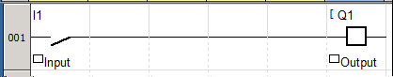
A truth table showing all the possibilities for the input and output.
Input | Output
0 | 0
1 | 1
If the input is on, then the output is on

17.1 AND Gate

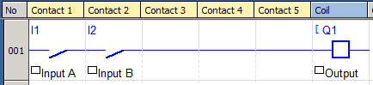
This circuit has two inputs and one output. They are all connected in series.
The Output is on if Input A is On AND Input B is on.
The following truth table shows all the possible circuit conditions.
Input A | Input B | Output
0 | 0 | 0
0 | 1 | 0
1 | 0 | 0
1 | 1 | 1

Symbol
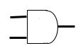
Obsolete Symbol
&
Consider the following circuit.
+24 Volts
+24 Volts
Input A
Input B
Output
Coil A
A1

Complete the following truth table for each possible input combination.

Input A | Input B | Output
0 | 0
0 | 1
1 | 0
1 | 1

Is it the same as the truth table for the AND gate?
If we have an unknown circuit that produces a truth table, the same as the AND gate. Then we can replace it with an AND gate and it is also equivalent to series circuit.
Input A
Input B
Output

17.2 OR Gate

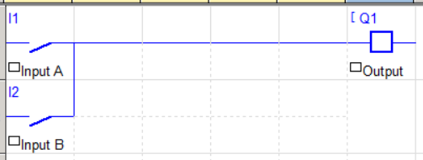

This circuit has two contacts in parallel. The truth table can be used to show the output conditions for the input possibilities.

Input A | Input B | Output
0 | 0 | 0
0 | 1 | 1
1 | 0 | 1
1 | 1 | 1

The Output is on if Input A is On OR Input B is on.

Symbol
$$≥1$$

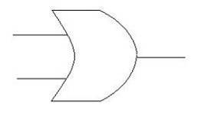
Obsolete Symbol
Consider the following circuit.
+24 Volts

Coil A

Output
Input B
A1
+24 Volts

Input A
+24 Volts

Complete the following truth table for each possible input combination.

Input A | Input B | Output
0 | 0
0 | 1
1 | 0
1 | 1

Is it the same as the truth table for the OR gate?

If we have an unknown circuit that produces a truth table, the same as the OR gate. Then we can replace it with an OR gate and it is also equivalent to a parallel circuit.
Input A
Input B
Output

17.3 Not Gate

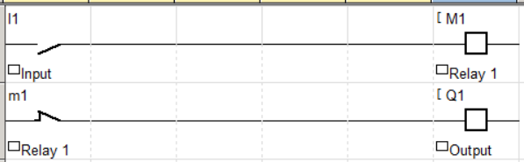

With this circuit the input operates Relay 1. A normally closed contact off Relay 1 is used to operate the Output relay.
When the Input is ON the Output is OFF and when the Input is OFF the Output is ON.
The truth gate for the NOT Gate is shown.

Input | Output
0 | 1
1 | 0

Symbol

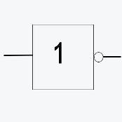
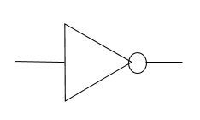
Obsolete Symbol

The “ο” shown on the output pin signifies an inversion. In relation to logic diagrams anywhere you see this symbol either on an input or output of a function then there is an inversion or negation.

Appendix A

Data Types
The table below shows most of the different types of data that the Unity Pro software recognizes.

Type | Designation | Format (bits) | Range From | Range To
BOOL | Boolean | 8 | 0 | 1
EBOOL | Boolean with forcing and edge detection | 8 | 0 | 1
INT | Integer | 16 | -32 768 | 32 767
DINT | Double Integer | 32 | -2 147 483 648 | 2 147 483 647
UINT | Unsigned Integer | 16 | 0 | 65535
UDINT | Unsigned Double Integer | 32 | 0 | 4 294 967 295
TIME | Unsigned Double Integer | 32 | 0 | 4 294 967 295 mS
REAL | Real | 32 | -E +/- 38 | +E +/- 38
String | String | Up to 16 Characters

BOOL – Boolean refers to a binary condition where a value is either on or off represented by the value 1 for on and 0 for off.
EBOOL - Boolean refers to a binary condition where a value is either on or off represented by the value 1 for on and 0 for off. The difference is that the PLC looks for either the rising or falling edge to cause a change from 0 to 1 or visa-versa.
INT – An Integer is a whole number in the range of -32768 to +32767. The most significant bit is the sign bit.
DINT – Double integer number. It uses twice as many bits as the INT and so has a much greater range of values.
UINT – Unsigned Integer. The most significant bit is not used as a sign bit so the negative numbers can’t be stored.
UDINT – Unsigned double integers. It uses twice as many bits as the UINT and so has a much greater range of values.
TIME – Double unsigned integer where the number represents milliseconds.
REAL – Real numbers are all numbers between a range of values so decimal values can be represented.
STRING – are characters that can be Uppercase, Lowercase and numbers up to 16 characters.
The variable can be located or un-located. A variable that is located is tied to a physical address in the PLC. That address could relate to the input and output connections to the PLC or specific memory files. They are accessible to other devices on the PLC network or SCADA systems. Un-located variables are contained in memory and used by the program but not accessible outside.

Glossary

Common Ladder Symbols
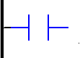 Normally open contact.
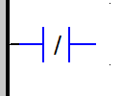Normally closed contact.
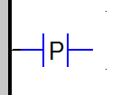Detects when the input makes a transition from 0 to 1. Stays on for 1 cycle.
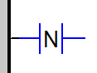Detects when the input makes a transition from 1 to 0. Stays on for 1 cycle.
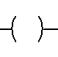 Output coil provides a logic 1 when on.
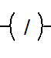 Negated output coil provides a logic 0 when on.
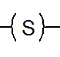 Output coil is set to logic 1, equivalent to latching on of a latching relay.
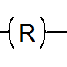 Output coil is set to logic 0, equivalent to latching off of a latching relay.
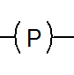 Output coil is set to logic 1 for 1 PLC cycle with a transition from 0 to 1.
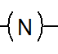 Output coil is set to logic 1 for 1 PLC cycle with a transition from 1 to 0.
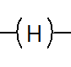 The PLC program is stopped immediately when this output is set to logic 1.
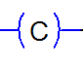 Call a Sub Routine.
 Used for creating Boolean (Digital) links between objects on the rung of the ladder.
Create a link between objects on the ladder for digital and analogue values.
 Jump controls, (Not recommended for good programming practice or used in low end PLC).
Data Selection used to select function blocks from the library.
Function Input assistant allows the entry of the variables for the inputs and outputs.
The function block selector is placed in the Project Browser window.
Change the state of the pin.
Add a label.

